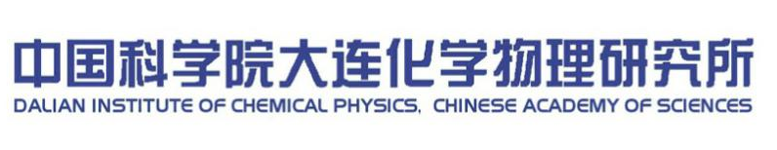


张大煜讲座提名表
NOMINATION FORM FOR DICP ZHANGDAYU LECTURESHIP

类别 Category
（请在对应选项前□内划√。Please check appropriate box.）
□ 张大煜讲座  DICP Zhang Dayu Lectureship | □ 研究所资助  DICP sponsored
□ 张大煜讲座  DICP Zhang Dayu Lectureship | □ 冠名自筹  Self-financed by the Research Groups
□ 张大煜青年讲座  DICP Zhang Dayu Young Investigator Lectureship | □ 研究所资助  DICP sponsored
□ 张大煜青年讲座  DICP Zhang Dayu Young Investigator Lectureship | □ 冠名自筹  Self-financed by the Research Groups

提名对象信息 Nominee Information
名First Name |  |  |  |  |  | 姓 Family Name
Mr./Mrs./Ms.
国籍 Nationality |  |  |  | 出生日期 Date of birth |  |  | 邮箱 E-mail address
所在单位 Organization
 |  | City/Province: Country: Postal Code:
职称 Professional Position Title |  |  |  |  | 专业方向 Discipline Category |  | 职务 Position Title (if any)
护照信息  Passport Info |  |  | 护照号码 Passport Number:
 |  |  | 护照签发日期 Date of issue:
 |  |  | 护照有效期 Date of expiry:
报告人学术亮点 Academic Highlights of Lecturer
报告人简历 Biography of Lecturer
 | 申请信息 Information of Proposal
提名理由 Project Justification
（简要说明邀请报告人来访对我所的意义。Briefly describe relevant impact of the project.）
项目后续计划 Project Sustainability
（简要说明在项目完成后，后续合作的计划安排。Briefly describe how the project will be able to deliver benefits after the conclusion of the project.）
 | 提名人 Nominator
 | 签名Signature: 日期 Date:
 | 研究室/组意见 Comments by the affiliated unit
 | 签名Signature: 日期 Date:

研究所审核意见 Review Comments
国际合作交流委员会专家评审意见 Comments by Experts Committee of International Cooperation
签名Signature: 日期 Date:

经办部门意见 Comments by Authorities Concerned
签名Signature: 日期 Date:
所领导意见 Comments by Directors of DICP
签名Signature: 日期 Date:

附件 Appendix:
（如有关于报告人其他情况简介，可另附纸说明。Please provide detail information of the Lecturer on a separate sheet, if any.）

1. 教育经历 Education and Training
2. 工作经历 Positions Held
3. 奖励 Selected Awards
4. 典型论文及专利 Highlights of Publications and Patents
5. 其他 Others（邀请报告 Invited Lectures, 杂志编委Editorial Boards， 等等 etc.）

