评分标准
所有打分均根据评分标准进行，并确保在70分以上。
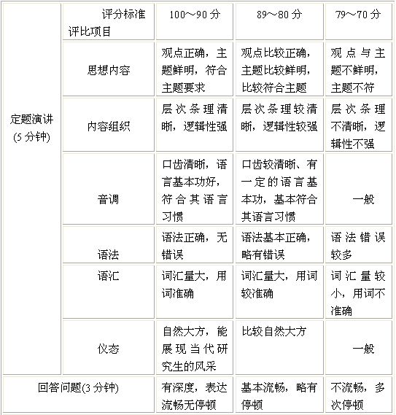
Speech Section (5 min) |  | 100～90 points | 89～80 points | 79～70 points
Speech Section (5 min) | Subject | Coincident well with the theme, good point of view | Coincident with the theme, correct point of view | Unclear subject and point of view
Speech Section (5 min) | Context | Clear and logical arrangement of the context | Nice | Common
Speech Section (5 min) | Intonation | Good pronunciation and nice cadence of the expression. | Clear pronunciation and expression | Common
Speech Section (5 min) | Syntax | Good sentence arrangement and nice grammar utilization | Correct sentence arrangement and grammar utilization | Common
Speech Section (5 min) | Vocabulary | Large vocabulary and good word utilization | Correct word utilization | Common
Speech Section (5 min) | Behavior | Good behavior and excellent presentation | Nice presentation | Common
Questioning Section  (3 min) |  | Smart answers with quick response and fluent expression | Proper answers with normal expression | Unfluent answers and inconsecutive expression

All the constants’ final scores would be marked above 70 points according to the following criteria.

